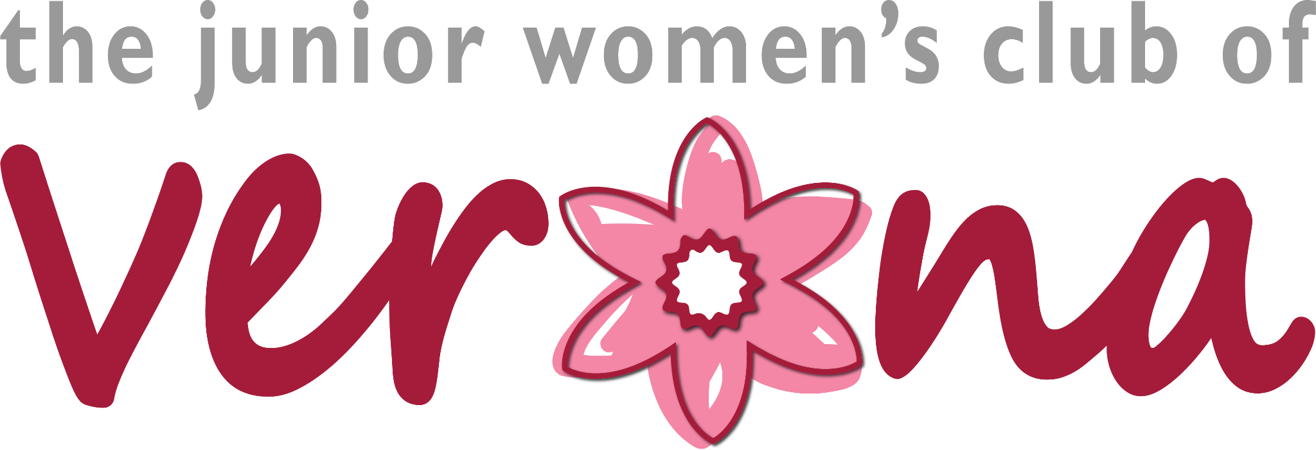

THE JANE MYERS SCHOLARSHIP APPLICATION
2024 DEADLINE: Friday, May 3, 2024

Late applications will not be accepted
*Applicants who do not adhere to the directions below will not be considered.

The Junior Women’s Club of Verona is awarding three scholarships of $1,000 each to any graduating senior that is a Verona resident, and will be attending an accredited degree-based higher education program (two or four-year college, trade school, or specialty school).

Awardees will be selected by a committee of Junior Women’s Club volunteers. Applications are reviewed via a blind application process (personal and identifiable characteristics are wiped for committee review). Awardees are announced in June at the VHS Senior Awards Night. If the awardee does not attend VHS, they will be contacted by a member of the Junior Women’s Club.

This is the application for The Jane Myers Scholarship: Selection based on commitment to the Arts. Note: You must be majoring in or intend to major in the Arts.

Part I - Personal Information

Name: Email: _________________________
Address: _____________________________
_____________________________________
*Applicant must reside in Verona, NJ
Phone: _________________________

Parent / Guardian Name:

G.P.A. ____________ Intended Major: ____________________________________

Check one:

I attend Verona High School.

I attend _______________________________.

Names of colleges to which you have applied or been accepted

Name of college/trade school/specialty school | Application Status (Applied, Waitlist, Accepted, Other)

I certify that the information I have provided is correct.

Signature:

Date

THE JANE MYERS SCHOLARSHIP APPLICATION
2024 DEADLINE: Friday, May 3, 2024

Late applications will not be accepted
*Applicants who do not adhere to the directions below will not be considered. Please remember that each scholarship that you are applying for needs an individual application, résumé, and essay.

PART II – Résumé/Short Answer (s)
Please provide typed answers in a résumé, list format, or short description. Answers in paragraph form should be limited to five sentences. Please describe:

- Work Experience
- Community Service / Charity Experience
- Clubs/ Activities/ Special Interests/ Hobbies
- Goals / Career Plans
- Academic / Other Awards received during High School

PART III – Essay(s)
Please provide a typed essay, 350 words or less, fitted to one page, about the following topic:

Show how an event or experience with the arts has impacted you. Explain how this experience has contributed to or shaped your future plans and goals.

Reminder to customize your essays for each specific scholarship.

RETURN COMPLETED APPLICATION, RÉSUMÉ, AND ESSAY TO:
Ms. Selene Rivera in the VHS Guidance Office
or
Email in PDF format to Manya Brachear Pashman at mbrachear@gmail.com.

